SECTION-01

1.1

SELECT *

FROM employees;

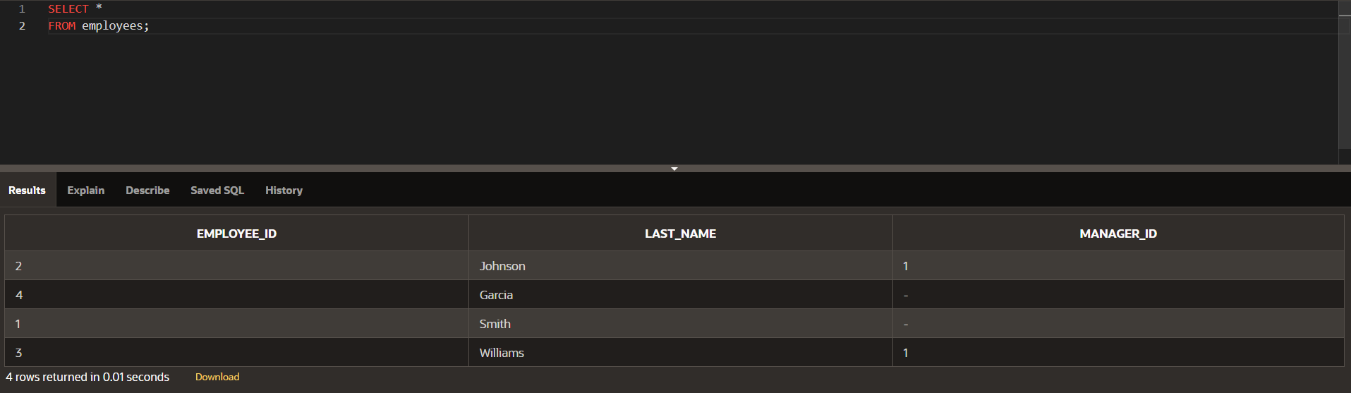

SELECT employee_id, last_name, manager_id

FROM employees

WHERE employee_id = 2;

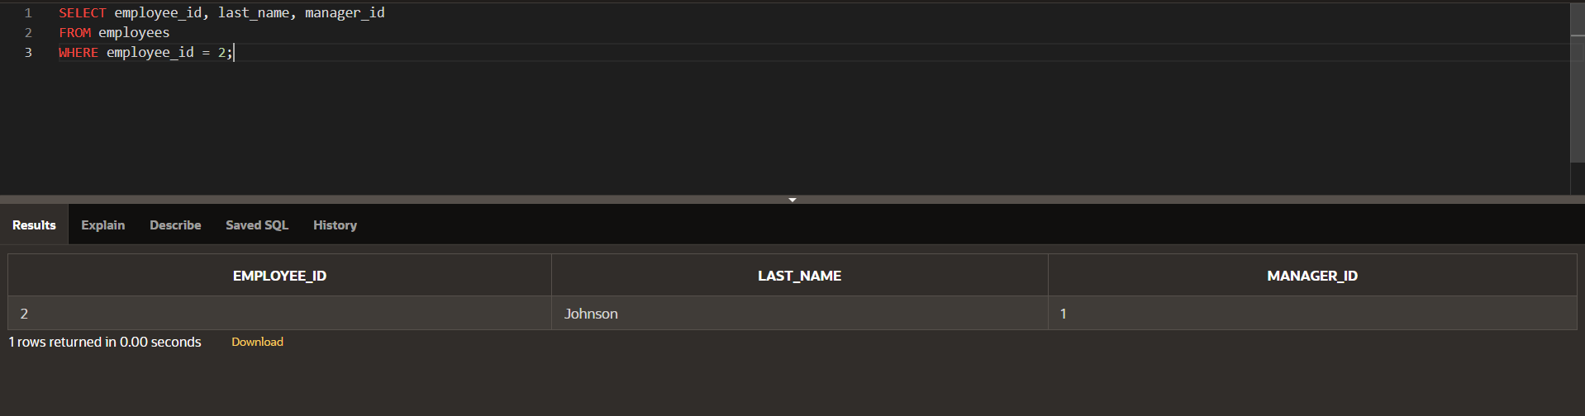

1.3

SELECT ename

FROM employ

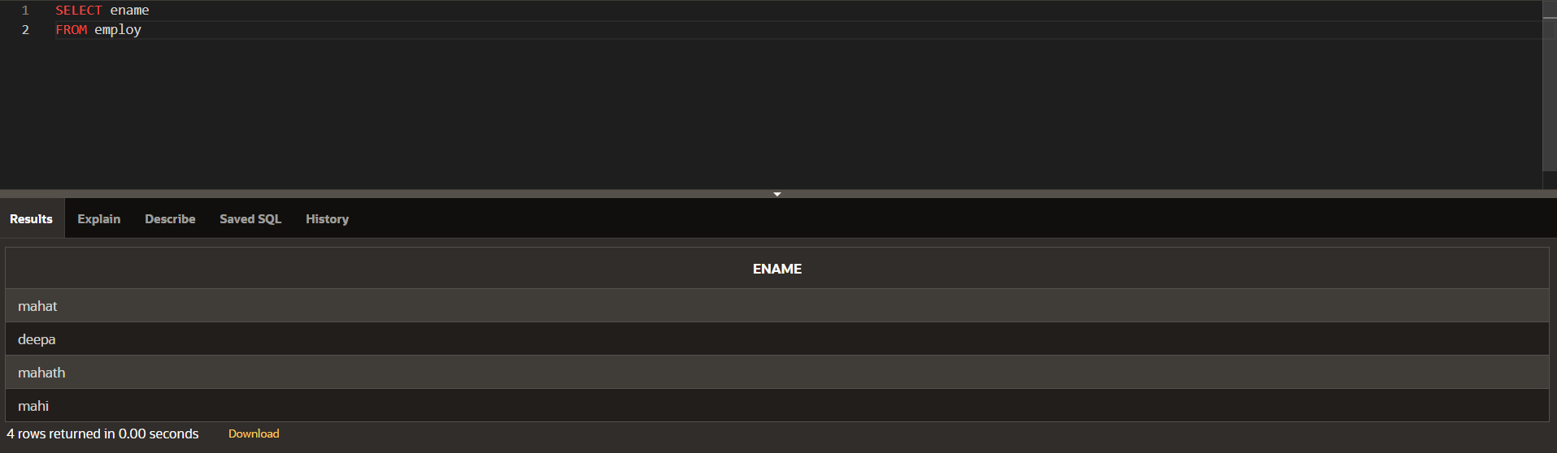

SELECT salary

FROM employ

WHERE ename LIKE

'deepa'

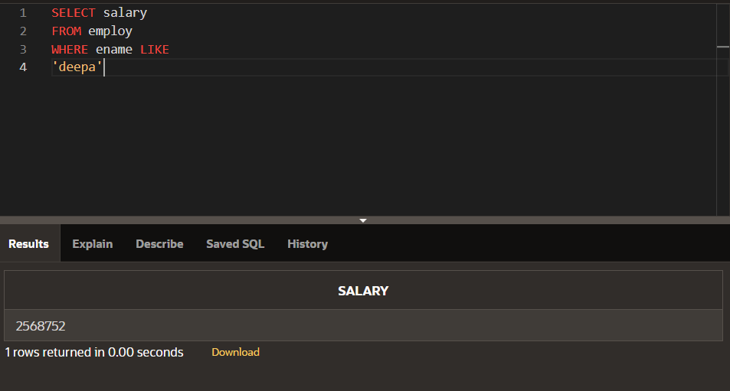

SELECT *

FROM employees;

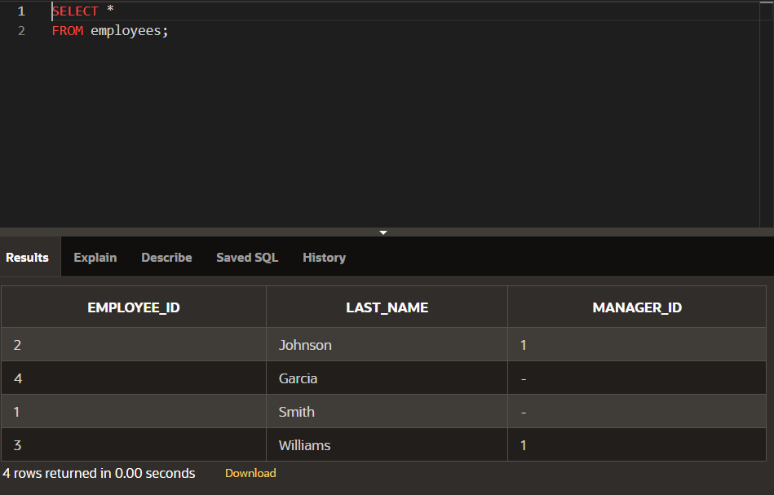

SELECT employee_id,last_name

FROM employees;

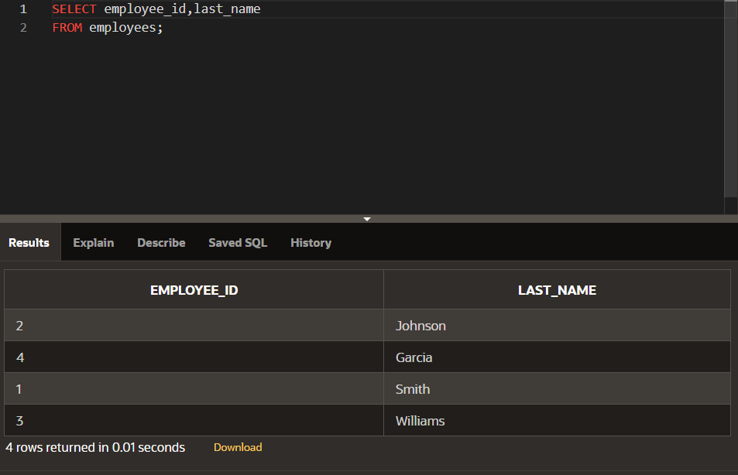

SELECT ename,salary,

salary+500

FROM employ;

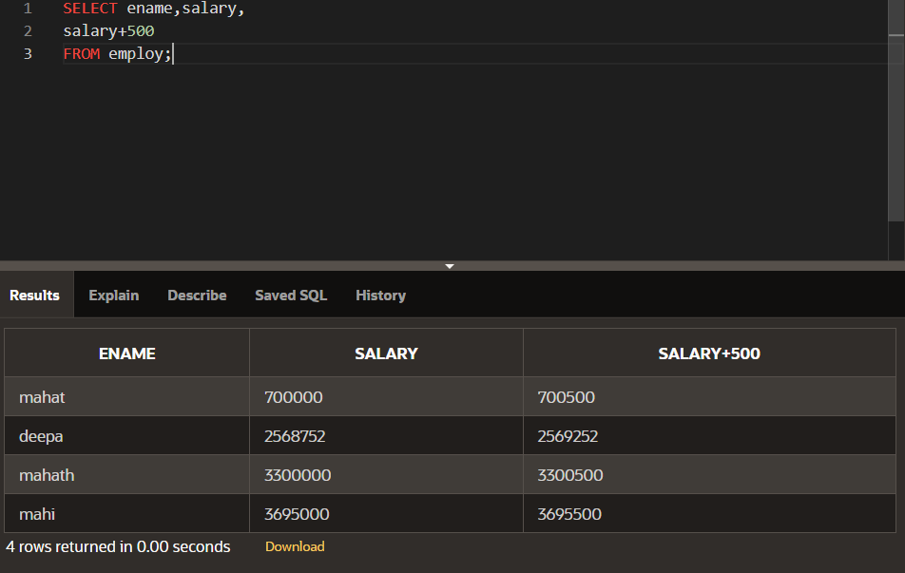

SELECT ename,salary,

23*salary+500

FROM employ;

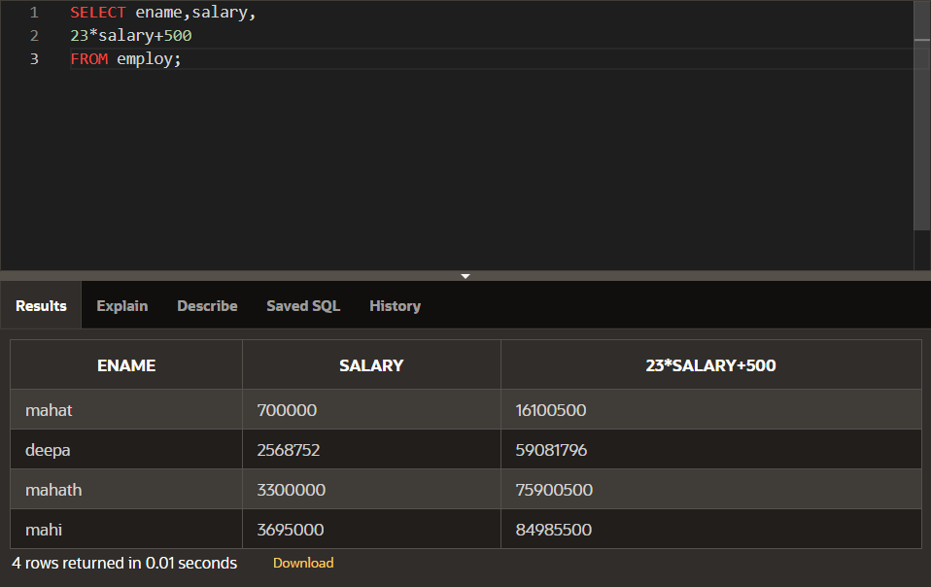

SELECT ename,salary,

23*(salary+500)

FROM employ;

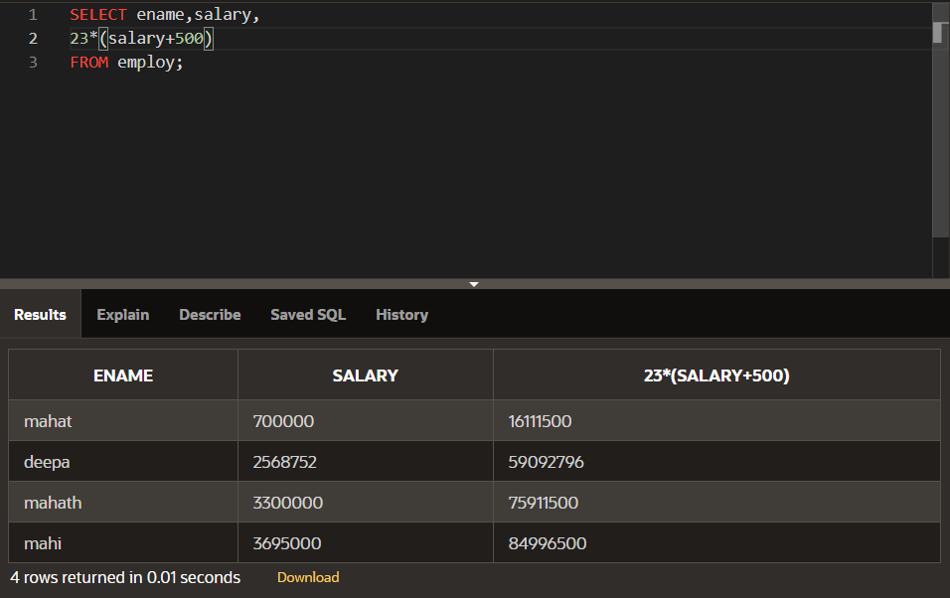

SELECT eno,ename,commission,

salary*commission

FROM employ;

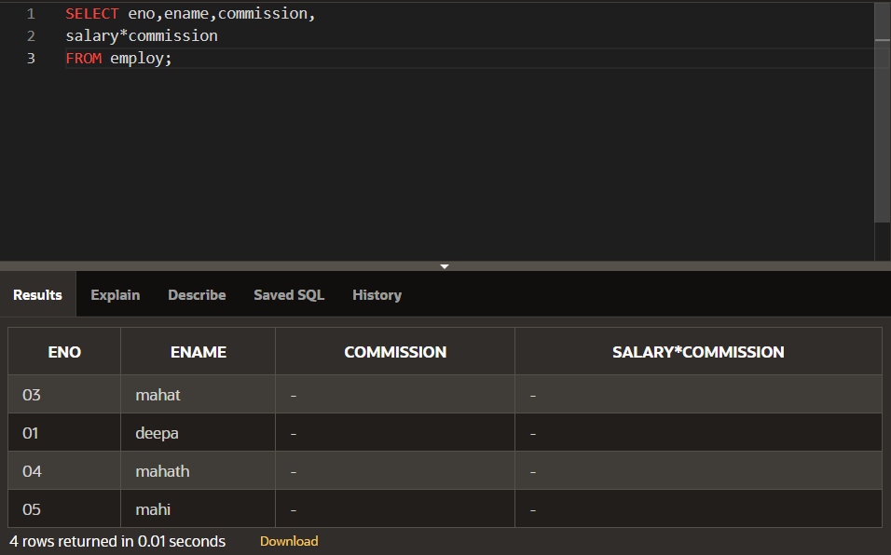

SELECT ename AS employe_name ,commission AS comm

FROM employ;

